Restorative Practice Questionnaire

A Student Engagement Initiative Project - Northern Region

March 2009

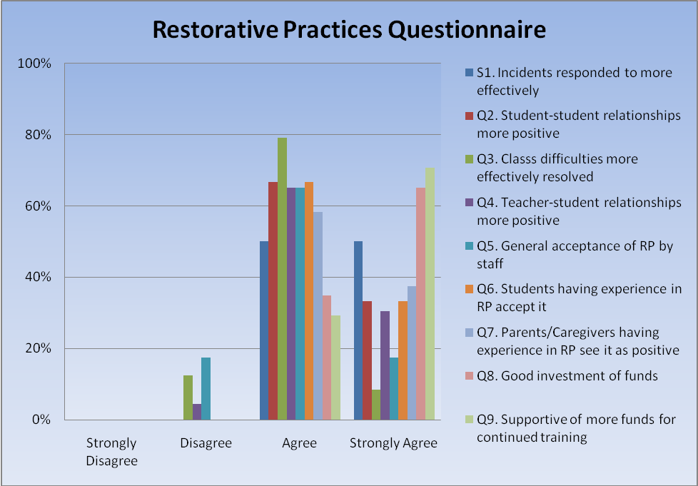
Statement 1: Individual incidents are now responded to more effectively through restorative conferences:
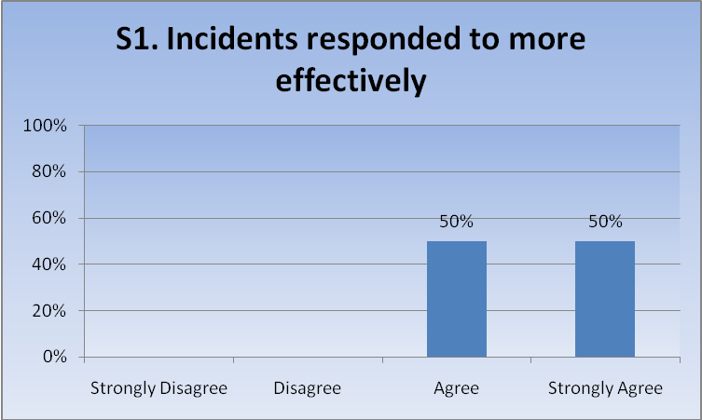
- Incidents from unresolved issues are less likely to occur; “Buy-in” from all involved is greater; no one wants to see failure.
- Depends on the type of incident that occurs. Which means generally speaking those that involve interpersonal differences are resolved quite successfully using restorative conferences.
- Restorative conferences used commonly in the resolution of incidents.
- All involved are able to express their feelings, effects of incident etc and all parties come to an agreement. Most conferences are chats at the time of the incident.
- In 2004 fights were frequent. In 2008, senior students are very clear with juniors that disrespect is unacceptable and have no hesitation in delivering students involved in bullying to the office for senior staff to sort out. New students to xxxxxxxx College have the highest incidents of bullying, fighting and disrespectful behaviours, once they have been involved in the restorative approach this behaviour generally reduces.
- Recidivism is very rare with students who have been subjected to RP – as opposed to those who have experienced other methods of correction.
- Students understand the language and setting used in formal arrangements and the responses usually result in a satisfactory outcome.
- We would have done over 70 restorative conferences in the previous year. A no blame approach often has more lasting results.
- In-school small conferences held; whole class also and several involving families.
- Used in settling class disputes.
- To bring about a true restorative culture takes about 3 years – we have until now focused on getting enough people trained to be able to take it out on a school-wide basis and really make a difference. We are just beginning this year. SLT and Deans are all using restorative practices and together with SCT have been involved in formal restorative conferences which had successful outcomes.
- High achievement rates; low exclusion rates; high retention rates
- Pastoral care – student management processes have been revised to include R.J. at classroom level.
- Incidents dealt with restoratively do not reappear later. Evidence in stand-down and suspensions statistics.
- Staff have been thoroughly briefed in restorative chats. P.D. has been included in Staff Meetings with staff having the opportunity to practice role playing situations.
- R.P. is not the first step in all situations. However, it is interestingly used in both small and big incidents. A problem is time.
- Better school tone; we use the language of “fixing it”; students understand it is their behaviour at fault not their own self; students are more willing to pass on info to avoid trouble happening; families involved are also learning the process; police constable using the process.
- When a RJ conference is used, students and families involved feel that matters have been resolved much more fully than if a decision “on high” was the solution. They are active participants and their opinions and feelings aired cont :… and valued by this process. Issues between students are less likely to continue bubbling away if RP practices are used.
- RP conferences are held as part of student incident management by Deans and at a higher level if students are stood down, often with parents involved.
- Regular “restoratives” held and referred to by staff/students.
- Witnessed some of the trained staff deal with incidents. They are resolved at a level that does not require statutory interventions – s/d suspension.
- Reduction in stand down and suspension rates. Much more “discussion” occurring about events and incidents. Has become part of the school’s behaviour management process, so staff and students should be having restorative conversations daily.
- There have been several cases of serious disputes or concerns between students and staff and students which have been successfully resolved in this way.
Statement 2: Restorative Practice has assisted in making student-student relationships more positive:
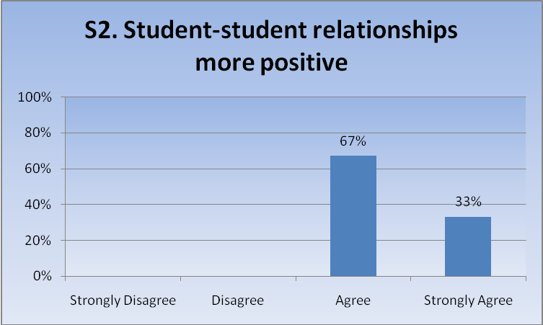
- In most instances where restorative conferences have been used in this situation a positive outcome has resulted.
- The whole philosophy of RP makes this so.
- Students become far more aware of the implications of their actions on others
- Students who have been involved in issues and then undergone restorative conferences often make friends and have been observed working together and being involved in activities together
- Damaged relationships have been healed with little (if any) evidence of further destructive actions.
- Students value the opportunity to be heard (as a victim) and are developing good communication skills.
- Forces both student and teacher to own their behaviour and feelings. It is a way forward when relationships are stuck. Students and teachers must acknowledge positives.
- Students have been trained as mediators; refresher training and new mediator training annually; student response to surveys.
- Works well in guidance and some deaning situations.
- So far, really only when there has been a problem and restorative has been successful in resolving it. We haven’t yet got to the stage where it has had an impact on the culture of our school – next step.
- Parent feedback; staff feedback.
- Students involved in R.J. on a day to day basis as necessary.
- Have now set up a student-driven, school-wide system of trained student peer mediators.When used in class the process allows us to explore alternatives to violence in a non-threatening way. The collective message is that no-one wants the violent behaviours – including students (especially friends) and it becomes a problem for all the school community not just a few victims or perpetrators.
- Student relationships have benefitted. Less of the grudge and victimization behaviour.
- Students report positively on their evaluation of R.J.’s. They have reported through a national health survey conducted by independent researchers that they feel safe at Xxxxxxxxx College.
- R.P. gives students an opportunity to reform and for other an opportunity for justice.
- We have found students consider the process in quite a different light from the usual disciplinary processes. They find that if they listen, and are listened to in turn, good resolutions can be agreed to. While they might not always end up as friends, they are much less likely to harbour resentment, etc.
- Students now have opportunity to “front up” to issues rather than hiding behind an incident being dealt with only by the dean/deputy principal or staff member. An example would be two students fighting would now both need to be part of a restorative conference. Still work to be done with students – our intention is some ‘training’ of our senior students as part of peer mediation.
- When dealing with students in Restorative Conferencing, there has been positive outcomes for all parties.
- reduced incidents, incl. suspensions.
- Students get the opportunity to see how others are affected which they often didn’t think about. It gives the students the opportunity to look after other alternatives to their actions – also a chance to apologize and so move forward. Helps students understand the other part a lot better.
- One case above was a clear choice between suspension for harassment after numerous warnings or a restorative conference. After months of harassment from both parties, the matter ceased immediately. Both girls continued on successfully at school.

Statement 3: Individual class difficulties are now more effectively resolved through the use of RP strategies:

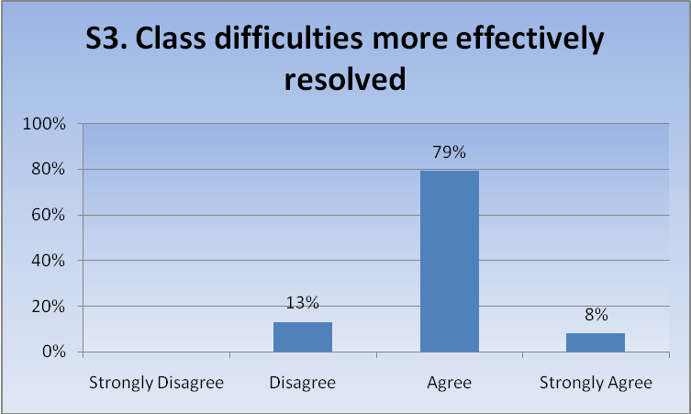

- We have not done many class restoratives lately.
- More teachers are able to follow the script with confidence when faced with a class conference. Work still has to be done to bring up to speed the few reluctant staff who do not work with RJ model.
- Classes that have displayed any dysfunction issues have, through RP, been corrected with a high percentage of continued functionality.
- Where we haven’t used the classroom processes of dealing with conflict, there have been major relationship issues.
- This is not yet evident in classrooms. Most conferences /chats take place outside the classroom. Next step is to involve teachers in more of a leadership role. *
- RP strategies are implemented through the guidance, deans and SMT – not yet at the stage of classroom teacher training but still these strategies have been and are being used by pastoral care staff.
- There have been some very good class conferences which have been shared with staff. We haven’t kept a formal list of them, but many students have asked for them. We have also had some which haven’t worked so well.
- Working in 50% of cases. Being developed.
- Some good use of classroom conferencing to support the turning around of a negative classroom culture.
- However, this is dependent on the effectiveness of the R.P. and the facilitators. I have seen some poor results when the process has been done badly.
- This is on-going work with some teachers who themselves may need to be more assertive about expectations.
- Done with x2 class groups and works well.
- This is an area in which we are most weak, mainly because of some poor quality teachers unable and unwilling to take on the restorative culture – i.e. put in the time. 15/45 teachers where most of the classroom discipline problems occur.*
- Staff who have engaged in class R.J.’s report positively on the outcomes.
- We have not conducted very many whole-class conferences, but when they have been used that have been very effective. Again, all voices can be heard – sometimes the quiet ones have the chance they’ve always wanted.
- One dean in particular uses ‘class RP strategies’ and this is effective – more work needs to be done in this area.
- Because RP is part of our behaviour management system, staff should be finding this the case. However, there is still some learning to occur. It is very apparent, however, in any staff member who has completed the training.
- We use restorative conversations after a student is referred out of class for poor behaviour. When carried out properly the effectiveness is good.
* These two schools responded with a “Disagree” to this statement.
Statement 4: Restorative Practice has assisted in making teacher-student relationships more positive:
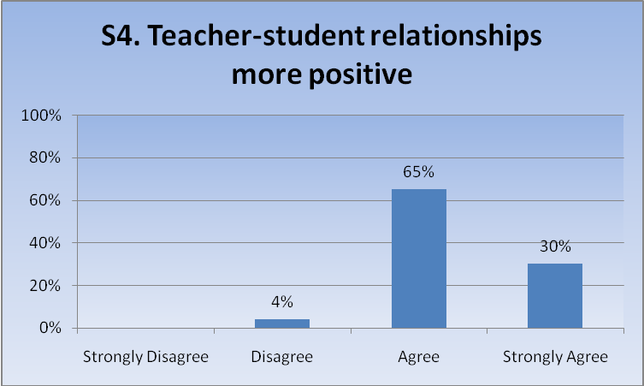
- Where used – yes.
- Ensuring that the desired outcome is to build positive relationships and to resolve issues enables issues to be heard – and resolved.
- Gives teachers a consistent script they can use to help restore situation in which the relationship has become damaged.
- Staff meeting minutes
- Student-staff feedback.
- But on a small scale – it’s really confined to the few who have had restorative conferences. It has also made a big difference to some as a result of the training with Marg Thorsborne – an immediate change in practice. We now need to build on this.
- In most instances where there has been conflict between teachers and students are restorative meeting has proved successful where both sides are prepared to compromise.
- The outcomes of conferences clearly indicate this to be the case.
- Especially with the staff who lead the conferences/chats.
- Nine times out of ten when a student/teacher/parent conference is used all parties have had their say and have found a way in which to work together. Because this is a blame free process, and the teacher often makes concessions or puts in additional supports to help the student the relationship issues between them are improved. Very few of these conferences have to be repeated with exactly the same participants. The spin off is that the teacher also learns to work with other students in a different way which helps relationships.
- An understanding of both party’s perspective is gained frequently resulting in strong and workable teacher/student relationships.
- Not withstanding the few who still require modification, students are able to approach staff knowing their issues will be addressed.
- As stated earlier, it is a useful way to help repair damaged relationships.
- Some students are more open to dialogue.
- For staff who employ the R.J. process in its entirety, this statement is most definitely true.
- The majority of teachers would agree to the benefits it brings to relationships – 25/45.
- No question about this, when a teacher is prepared to take part in RJ practices, their rapport with the student[s] concerned is greatly enhanced. Both sides gain an understanding of the other’s position and the dignity of everyone is preserved, Again it has a lot to do with listening and respecting.
- Many staff involved in a restorative conference comment on how empowered they feel at the end of it, and how it allows them (and the student) to move on. Staff who are using ‘restorative language’ in their classrooms are finding the relationships more positive.
- encouraged greater staff-student talking.
- This has been a real strength. Students and staff are able to make the other party more aware of their feelings and helps them understand better the reasons for actions.
- One memorable case involved a Maori staff member and a Maori student. A restorative hui was used involving our DP as facilitator, assisted by Kaumatua. This was a very successful hui.

Statement 5: There is now general acceptance of the benefits of Restorative Practice by our staff:
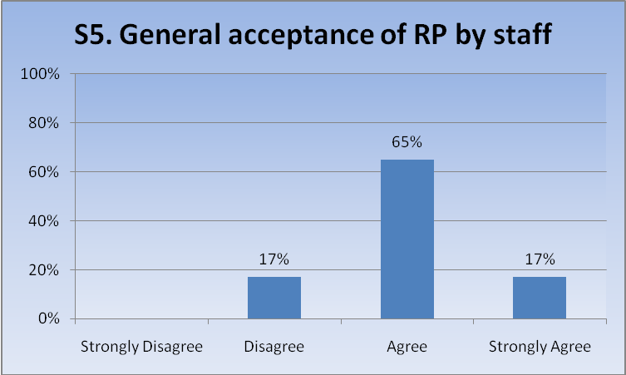
- We have a very big majority of “buy-in” but now need to ensure we “get it right”. Minutes of staff meetings at the end of last year and beginning of this year show the support and positive reaction to Jude Moxon’s P.D. (on becoming a “Restorative School”) held recently.
- I do not employ staff who cannot work restoratively.
- Staff meetings; P.D. sessions.
- Whole staff training and forum for issues to be raised.
- I am unsure about the levels of understanding, skills and practice in this area.
- Not enough evidence to support.*
- Less reliance on detentions; more frequent conferencing.
- Most are sympathetic to restorative practices.
- Although the majority would agree, the minority (of 15 or so) still persist in undermining the benefits of R.P.. Their language used to describe RP is “soft and weak”.**
- There is still work to do in getting the R.J. process sold to all staff. This was anticipated and the Breakfast Club meets regularly to plan strategies to keep the R.J. process in front of the staff.
- We are able to identify those staff who do not subscribe to this practice very easily by way of the number and type of referrals as well as student comments.
- There is general acceptance i.e. probably 70-80% of staff willingly adopt RP in addressing issues – others come on board as results are witnessed. Some may never.
- The whole staff believe in restorative practices and work with the restorative chat in the classroom being the first part of the resolution processes. If this hasn’t happened then the issue is referred back to the Teacher by the Dean and they are told to do this. If the issue ends up at the Dean then the Dean facilitates the Restorative meeting with the staff and student concerned.
- Teachers still need to be reminded of RJ practices as opposed to deficit model.
- Staff are mostly aware of and impressed by RP. The philosophy underpins much of our practice.
- Staff have been relatively slow to accept the benefits of restorative practices as the ‘be all and end all’ of solutions to individual and group conflict, however, most would agree it being one of the tools to be used in the system as a whole.**
- Full staff training is required. Some suspicion still exists. We have a conference planned for May.**
- From time to time, presentation have been made to staff meetings – either abridged case studies, or demonstrations of various techniques, such as Restorative Chats. On one occasion teachers who had been involved in a conference concerning a serious matter spoke to staff about the experience – she had initially been very reluctant to take part, but after the conference she was a real convert, and spoke with great enthusiasm to encourage staff to use Restorative practices whenever possible.
- All staff who were employed in 2008 attended a 1-day session and then on-going PD sessions. Many staff were involved in RP conferences and it has become part of the way we manage incidents.
- It is now an accepted programme at our college.
- People keen to come on board. We are planning to start a breakfast club in Term 2 (an idea stolen off another school). People, who are keen to be proactive, have put their hands up to be the RP ‘go to’ person in their departments. Some staff still don’t get it!
- This acceptance is growing as the benefits of practice are recognized. Staff are willing to train.
* There was no qualitative response to this statement by this school
** These schools responded with a “Disagree” to this statement.
Statement 6: There is acceptance of the benefits of Restorative Practice by students who have experienced it:
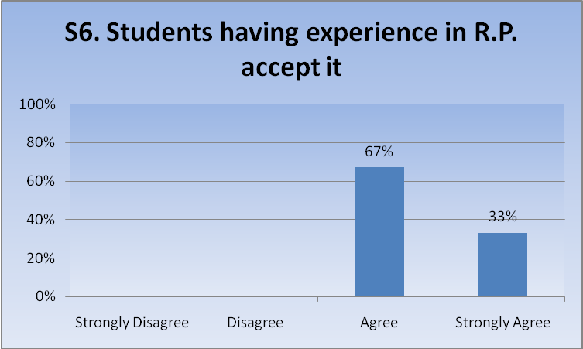
- Positively supported by those students who have used the process. In fact a year 8 student suggested to me that I should consider the meeting circle thing rather than suspending a new student who had been fighting.
- Students are responsive to RP and are generally always accepting of outcomes. There is often an appreciation of the process as a provider of a second chance – i.e. an alternative to suspension – and that is grasped by students and whanau.
- (But) one has to be aware of students who slyly manipulate the system and have learnt ‘what to say and when’.
- Most are very happy with the outcomes as evidenced by follow-ups.
- Some students involved in R.P. last year still at our school and better engaged in learning. Feedback from parents is positive.
- Students who have been through the process report positively on the experience, particularly on the reviews that are held further down the track to check on relationships.
- Most students have indicated that they felt that the process was fair and the outcomes agreed upon were to the benefit of everyone.
- Most definitely. Students see the benefits immediately and their whole behaviour patterns change for the better.
- Most students who have participated in R.P. meetings now seek this as a first step to avoiding conflict and violence.
- Yes – seems that they think about it a bit more.
- Students know their issues and concerns will be addressed in this way and follow-up does happen.
- Students ask for it – class conference. They are happy to be assisted to sort things out in a restorative manner and they take it seriously. Lots of positive feedback – evidence is anecdotal but would be easy to get hard evidence if we needed it.
- They get to have their say.
- (We)Survey students on an on-going basis to assess whether the restorative action is effective.
- Students respond very positively and are grateful for the opportunity to fix something rather than be condemned for it. Also families speak of the better opportunities that RP gives for learning.
- It has been rare to find a student who has not felt better following a conference, even those who were “in the wrong”. Once they understand the process they take it seriously and make progress towards an understanding. The skill of the facilitator is a factor here.
- Some would be unaware that they have been through a restorative practice meeting as such … but a number have commented on how good it was to tell their story, and to hear from the other side as well. We don’t necessarily refer to a meeting as an restorative practice conference, more often it is about having a meeting to ‘right the wrong’ or ‘fix the issue’.
- Students gain a much better understanding of the reasons behind actions of others (and their own). Offers a forum to formally apologise and move forward.
- The outcomes support this.

Statement 7: Parents/Caregivers who have been involved in Restorative Practice see it as a positive strategy:
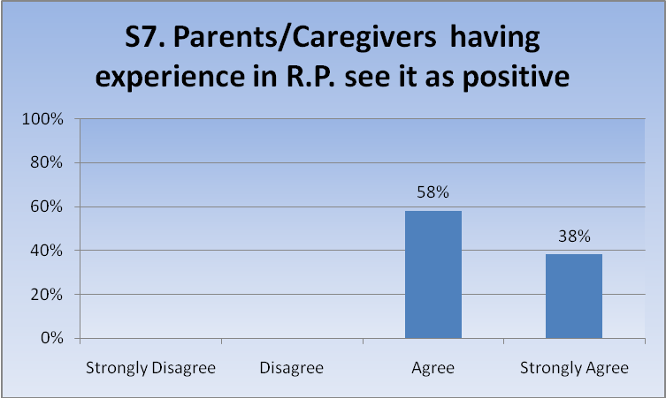
- Strongly agree – great benefits.
- Parents have been overwhelmed by the openness, the fairness and the restoration of each person’s mana involved in the process. We have not had a negative response in evaluations to date.
- Parents involved are grateful for the opportunity to be a part of conferences and see it as a powerful tool for their children and for themselves
- Most parents see it as a positive initial tool when conflict first arises.
- Usually supportive of getting a resolution that will work.
- Parents are relieved that they are given support to achieve a positive outcome for their child even if it entails availing themselves during work times, most do.
- Feedback dictates this – see above response. There has been only one instance (in my experience) where a parent has opted to discontinue with the conference – due to difficulty in accepting the student had done as alleged.
- Caregivers who have been exposed to the process the first time are often reluctant but if they have to come back over other issues a second time are really happy to be involved and see this as a positive means of changing the behaviour, fixing the problem and ensuring that their child gets and education.
- Positive feedback from parents.
- Conference feedback sheets
- Not enough high-end conferences any more. Parents do not get to see the “full Monty” often.
- Extremely positive feedback. Willingness to participate. Again anecdotal.
- Parent comment following participation in conferences.
- In guidance – yes.
- This has been an excellent process for parents to have their voice and for others to hear concerns. It has been the making of good community relationships.
Some feedback has been positive. Some parents are still unsure.
- We have not involved parents in very many conferences, but on one occasion the parents of the ‘victim’ felt that the process had exposed the harsh punishment that had been meted out to the ‘culprit’ by his father – they were upset by the knowledge and wished they had not learned about it. Their expected outcomes were confused; they wanted to point out that their son had been wronged, but felt horrified that his father had punished him for the matter. However, the teacher conducting the conference was able to point out that this in itself was a learning situation for all concerned.
- Parents want to be involved and want to meet other parents/students involved. Appreciate the way conferences are run and feel they are part of the solution to the problem.
- Feedback has been very positive.
- Not all parents are aware that they have necessarily experienced a restorative meeting. However they have been impressed at what has happened in the ‘meeting’. They prefer these conversations to the punitive consequences their child may have suffered in the past. A couple of parents have commented that they would like to adopt the principles at home when we have talked about the language of RP with them.
- They appear to get right behind it and value the opportunity to put things right rather than serious discipline being carried out.
Statement 8: The funds spent in Restorative Practice training has been a very good investment.
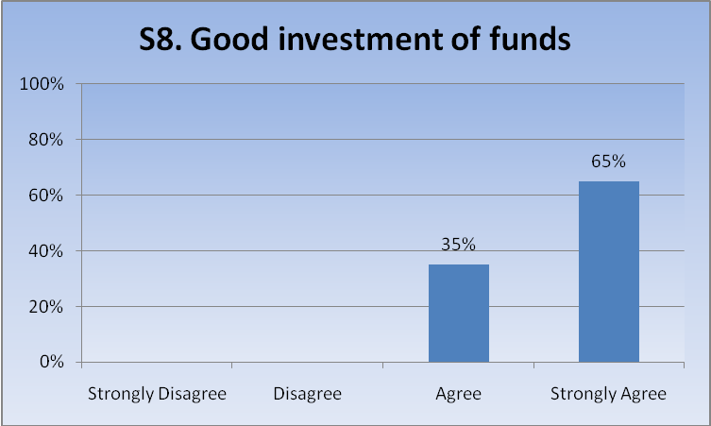
- We do not have the funding at this stage to fund it properly nor to ensure effective implementation.
- Training/release – so yes.
- We need to get the rest of our staff trained a.s.a.p. , and now have people asking for training. Without SEI assistance we simply could not do it. Last year we spent $7,000 just in relief for training, and without having to pay any of the course costs!
- We commit $4,000 out of $19,000 P.D. to restorative each year.
- A decline in supervision rate overall.
- Yes – would be very expensive otherwise. On a yearly basis expenditure involved in this allows for a sustainable
approach by increasing the number involved.
- The use of Restorative Practice when conflicts arise is now imbedded in our Student Support procedures when conflict issues arise.
- The more staff trained as facilitators the better RP are embedded in the school culture. It has taken us 3 years to get to where we are now – pleasing progress. Those at the frontline have to hold onto the big picture.
- The whole staff are trained in the use of restorative practices, we all use the same language. We did not have a good year last year in terms of using the processes and this was the direct result of the two new Deans not receiving the training until the middle of the year. This had a big impact on the behaviour in the school and the slow response to the change of attitudes in the new and younger students.
- R.P. is developing the confidence of staff in the school.
- Our attendance data and the drop off in playground incidents such as fighting has been noticeable.
- Without Restorative Practice in the school we would be almost totally committed to punitive responses when addressing issues. Punitive measures have little effect as any SMT member in any school will testify if detention statistics etc. are used as an indicator.
- The trained staff have been able to advise other staff / do staff PD / assist in class conferences where needed.
- There is a need for many staff to be able to facilitate restorative conferences. Training makes staff more familiar and sympathetic to the philosophy and processes.
- The money has been used for attendance, transition, statistical data.
- Our college could not have afforded the cost to train so many staff – we are grateful for the SEI input that has allowed us to set a firm platform for the continued development of RJ in the College.
- An absolute blessing. We would never ever have been able to have done any of this without them.
- Has been essential to our development/implementation of RP.
- Staff deal with inappropriate behaviour in a positive way. Students don’t feel ‘picked on’ and feel they are treated with respect.
- The fact that RP is used more and more supports this. Trained staff look to RP as a clear option.

Statement 9: We are supportive of the use of further funds to continue the training of staff in Restorative Practice.
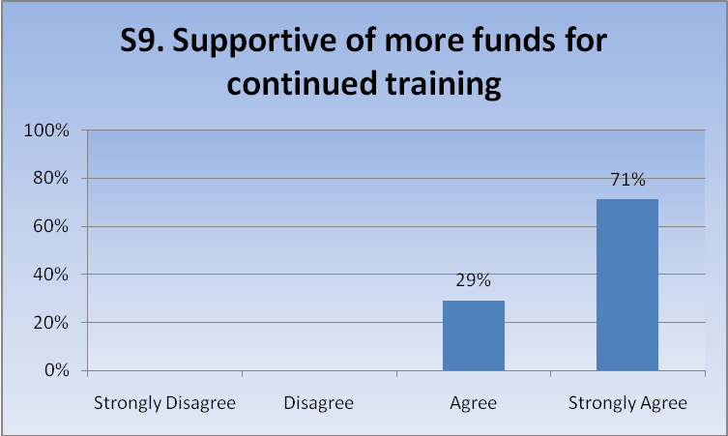
- The use of Restorative Practices to resolve low level conflicts between staff /students and student/student is seen as a positive contribution to our student support procedures.
- To maximize the benefits across the school we have to be committed to allocating funding to enable all staff to be trained.
- I believe that it is very important for there to be ongoing professional support and discussion about the best practice in the use of Restorative processes. In order for the process to be consistent across all practitioners, for effective use of the process to effect behaviour change, to learn to empathize with others it is important that all staff are skilled in the use of the process and keep up to date.
- As staff roll-over occurs, the necessity to gain quality training is unquestionable. WBHS has and always will provide some training for staff in RP, however for the senior members of the pastoral care system – those who are running conferences and dealing with the serious issues – training from a professional is imperative.
- However these funds need to be subsidised to allow more staff to participate in PD in one calendar year to create an impetus of like minded staff.
- Training is expensive both financially and in the time away from the classroom. However it is important that we train new facilitators and that teachers new to our school are aware of the processes and philosophy.
- This is a future plan.
- We need to employ a full time restorative coordinator as a major next step.
- We are pleased about the number of trained staff we have at present. However, I believe that all staff need to train in order to establish the confidence in the R.J. process with each individual.
- Would support this.
- Refresher sessions are always important in maintaining commitment as well as ensuring new staff know our practices.
- If we are to bring about a truly restorative culture we need everyone to be trained a.s.a.p.. The system we are setting up is the 20 trained staff dealing with students in a restorative way for the other 60 staff. It will cost us $36,000 in relief (lessened if the 3-day training is in the holidays) and would cost us $27,000 if we had to pay for Marg as well. We have already had time with J. M., and released those 20 staff for a day for training – with a total budget of $40,000 and a new curriculum we need all the help we can get to bring about any real change.
- R.J. interventions are part of school strategic planning.
- Too expensive for schools to do on an individual basis – good to train with teachers from other schools – establish a network.
- Conference day booked with Marg Thorsborne.
- We believe it is important to continue to train more staff – younger staff have a great influence on students, and with a good understanding of RJ practices they get the message across to more students. Their ‘leading by example’ cannot be over-estimated. Many of the young Polynesian teachers are our role-models for our senior students, and their use of RJ exemplifies a different, less confrontational way of dealing with conflicts and crises. They can teach tolerance, kindness, empathy, consideration, courage etc by using these methods.
- All our Deans need to be trained. We have 4 new Deans this year whom we are planning on training.
- Essential resource.
- I now have a waiting list of staff who want to do the training!
- We would love to gradually train all our staff. We are determined to see all Deans, SMT and HOD’s trained first.
General Comments:
- We are at the beginning of our restorative journey. We have established a team of staff who are passionate and willing to lead the way forward. The school as a whole is currently working on establishing a culture based on relationships to aid in the process. This will include drafting of a policy and procedures.
- Xxxxxxx School is well down the track in the development of a restorative culture. R.J. training is a feature of staff meetings and teachers are encouraged to utilize R.J. principles as part of their everyday classroom practice. Our Student Management Process has been reviewed this year to ensure teachers initiate “chats” to deal with all “low level” incidents before they are referred on to S.M.T.. A student will engage in restorative discussions at all levels – including stand down and suspension situations.
- I am disappointed that new teachers are not already trained. The on-going cost of keeping a restoratively trained staff is high.
- Think I have written it in the other pages. We have 25% of the staff now trained and enthusiastic about establishing a restorative culture in the school. We have had some very successful “full Monty’s” but there is a concern about the amount of time they take to prepare for them – seen as worth it but a practical consideration. We have had different people and others observing – good for of P.D. as even after Marg’s training, not everyone felt confident enough to facilitate a full conference. Interesting that the unsuccessful ones were led by an R.T.L.B. who had not undergone the training. Last year staff were pulling their hair out over the “difficult students” they had. We have overhauled our student management system (discipline) and have a huge buy-in for a restorative approach. We think this will free us up to be able to work more intensively on interventions for the “hard core”. After reading an article about R.P. in Pallisades High School we were keen to try a similar model in our school as it fits our philosophy well. Marg Thorsborne put us in touch with JM. who has established something similar in Massey High School. The strength of ours (if we are successful) is that we have 20 people who have offered to give 1 hour per cycle to make this work – it’s not dependent on one person and wont fall over if anyone leaves. This is an exciting year and I have already had several people ask me when they can have the training! This is also something that we can definitely sustain ourselves once we have all our staff trained.
- Use of restorative techniques must go hand in hand with understanding of cultural needs; support from specific cultural groups; bravery/courage on behalf of all participants; funding/monitoring and on-going support for professional development, philosophical exploration, coaching and monitoring towards excellent practice (this is lacking at this stage); development of behaviour management schemes; commitment by leaders, teachers and students to the process. Records show that 1 staff member participated in whole staff P.D. for Restorative Justice. 3 teachers remember it “being mentioned at a staff meeting”, therefore only the Social Worker and I have had P.D. in it. (Comment by recently appointed Principal.)
- We are looking at giving all staff some refreshers/introduction to restorative processes. We are aware that our Deans and new staff need more training. We want to build on teachers use of the restorative chat.
- We have developed a low-level RP reflection sheet(A) for use by classroom teachers; we are planning a second sheet. We plan to move to a house structure to elevate the role of the dean to House Leader and Leader of RP. We have scheduled a RP training day. The greatest enemy is busy-ness and time to conduct RP conferences.
- In my opinion the RJ process has been one of the most fulfilling initiatives that we have introduced at Xxxxxxxx College in my time here. It is five years since we started down the RJ track now. The core group that ensure the RJ initiative is kept before the staff is the Breakfast Club which meets Tuesday mornings to discuss and plan how we continue to progress the RJ initiative within our school. The students in particular are familiar with the RJ chat cards that all teachers are encouraged to carry on them at all times and to use as the occasion demands. The RJ process has slowly but surely been embedded in the culture of the school. This has given rise to changes in school policies to bring them in line with the RP way of doing things, An example has been the Behaviour Management Plan that has been part of the discipline process of Xxxxxxx College for the past 3 years,. This has been rewritten to reflect the RJ way and is also renamed the Learning Management Plan.
- Xxxxxxxxxxx School has had Restorative Practices embedded in the Pastoral Care system for around 10 years. The school is not yet a ‘Restorative School’ however I firmly believe that at some stage in the not-too-distant future that title will be adopted. Because we experience the benefits and successes in engaging in RP it is growing within the school to a point where subject teachers (not with any management status) are requesting that they go on the three day courses so that they can run conferences as they have experienced. Unfortunately, due to other necessary PD demands, Xxxxxxxxxx School cannot afford to send all the staff members, who choose to be trained, on the courses. There is significant pressure placed on the PD budget just in keeping Deans and SMT trained – due to staff roll-over. When prioritising budget, curriculum expenses are at the top then comes staff training and up skilling to teach to NCEA requirements, new curriculum and a plethora of other subject related issues. If RP training were to go higher on the priority list – something else must fall off. The reality is that there just is not enough money to cater for all the things that a school requires to run efficiently. If Restorative Practice training is to be discontinued the effects on teaching and learning within this educational institution will be severely compromised.
- Restorative practices are imbedded in the culture of the school in our strategic goals, in our prospectus, play an important part of the enrolment process and the discussion the principal has with each individual parent about how we deal with discipline issues in the school. The board are given professional development into what restorative practices are and how they influence the changes in our students. The school policy on dealing with disciplinary matters is to look at the restorative approach first and if all else fails then move to the punitive approach. The school models this approach and has used it to deal with disciplinary issues with a couple of staff. The use of this approach has significantly changed the way in which a staff member operates and the way in which the students see them. Restorative practices model aligns itself nicely with the Te Kotahitanga approach to teaching and learning. It is a framework which supports the theory of good relationships is the key to learning in the classroom. The restorative chat approach to small classroom issues aligns itself with the productive reasoning skills that the staff have been taught to use as well. All the tools kits are aimed at letting people have their say, issues on the table, seek a resolution repair the relationship and get on with the teaching and learning.
- Restorative practices are successful at our school because, in part, this philosophy is consistent with the school’s philosophy. Restorative practices give us the pathway to walk our talk. As a process, a high level of commitment is required, otherwise staff and students would come to believe that this approach is a weak way of avoiding dealing with conflict. Student and staff satisfaction needs to be continually monitored.
- Having been on the course we had adapted some of the class techniques and used them on withdrawal forms – encourages reflection. Early days with R.P. and need for funding and encouraging of staff to participate in training days. In principle it is very good. The reality of time is always there.
- RJ has been embedded in our culture over the past three years. The benefits have been that those staff opposed/threatened by the concept of RJ have moved on and there is no negativity in relation to RJ. RJ is our first option when working with students and their families where stand-down or suspension used to be that first choice. Relationships between staff, students and also their families are more positive and families feel more supported as they struggle to deal with their children with few parenting skills. The tone across the school is more positive, supportive, family-like because there is less punitive action and students know they are listened to, and that, for the most part, the outcomes are positive ones. It is critical that as many staff as possible are trained in RP to ensure that we are all rowing in the same direction. I am totally supportive of training being made available to as many teachers/support staff in as many schools as possible.
- Restorative practices are most successful when conflict is at a low level and in its initial stages. Quite often after a restorative meeting no further incidences occur. It is less successful when a student repeats behaviours which are unacceptable. Restorative practices are used within our Student Support system as one of the tools.
- At present we have a Co-Ordinator who has responsibility for the large conferences. In such a large, busy Decile 1 College it is a constant challenge to stop and remember to use RJ, but we do our best. There has been some very early discussion about the idea of re-writing our Student Behaviour Management System with the basic concepts of Restorative Justice at its core. It is too early to say whether this idea will be taken up, but the ‘suggestions’ will certainly continue. We believe that a SBMS based on RJ will have a very positive effect in terms of school climate, and increased acceptance of RJ practices.
- Restorative practice is now part of our behaviour management system, and will continue to be part of the way we conduct business. We see it as the key to establishing meaningful relationships with students (their parents and other staff members). Much energy is being put into academic counseling this year, and the relationship established between form teachers and students is key to this success. We are expecting the language form teachers to use will be aligned with that used in restorative practice. The language of RP occurs in our strategic and annual planning as we attempt to embed it into the culture of our school. We have a long way to go still, but we have both traction and an increasingly keen number of staff who want to be part of this.
- R.P. is now in our school’s culture and the key component has been the training provided. It is written in our policies and college-wide.
- R.P. has become part of the ‘Xxxxxxx Way” in the way that we respect others. All staff are encouraged to have restorative chats when dealing with students in the classroom. Class conferences are held in the junior school by Deans and all core teachers when the need arises. Deans and Senior Managers and the GC often hold formal conferences with students and parents. These have been particularly successful as part of the stand down process. As new staff join the school the challenge is to train them in RP and for all staff ongoing PD/reflection is vital to maintaining/embedding this in our practice. We have made it mandatory that all Deans will be trained in RP. We brought Marg Thorsborne over to Xxxxxx College last year for our PD day at the beginning of the year. We have also had Bill Hubbard run a PD afternoon session and Deans and Senior Management run the on-going PD on RP within the school.
- RP has not yet permeated everything we do nor may it. We see it as a tool which best fits certain situations and will seek to use it for these. Where there is clearly a perpetrator and victim, or even two apparently equal aggressors, RP can work well if the parties are willing to involve themselves. The other huge value for us has been the gradual attitudinal change that it is bringing to staff interactions with students.
Statistical Information:
- 24 schools responded to the survey; ranging in size from 135 students to 1501; in decile from 1(a) to 8; and enrolling a total of 17,312 students.
- 12 (50%) had their Principals who had undergone the 3-day training, and of those 12, 6 (25% of the total school respondees) had also undergone the 1-day follow-up. A further 1 had undergone a one-day training only.
- 49 members of school senior management teams had undergone the 3-day training; 19 the 1-day follow-up.
- 68 deans from those schools had undergone the 3-day training; 13 the 1-day follow-up.
- 34 members of school guidance staff had undergone the 3-day training; 12 the 1-day follow-up.
- 63 Heads of Departments had undergone the 3-day training; 1 the 1-day follow-up.
- 48 “other staff” had undergone the 3-day training (including 1 Board member); 7 the 1-day follow-up.
This is a total of 274 staff who have undergone the 3-day training; 59 the 1-day follow-up.
- There was, in addition, a variety of other statistical information provided, including a large number of staff who had delivered (and of course an even larger number who had “received) Professional Development in Restorative Practices; some schools who had contracted Marg Thorsborne themselves to deliver to whole staff; staff who had undergone other training of one form or another.
- Information on RP Conferences, class conferences etc were too ambiguous to be of any real value, as many completed these columns with ticks rather than numbers.
CONCLUSION:
There would be some value in summarizing the comments, statistics etc, as even where there is an apparent “negative” these are more likely to reflect the reality of dealing with some reluctant staff from highly motivated Principals who are finding that frustrating. No school made any comments which did not suggest support for what RP is doing in their school, and the majority were significantly enthusiastic.
Restorative Practice Questionnaire - Public
 |  | Statistical Data |  |  | 3-Day Participation
 | School: | Decile | Roll | Staff | P. | SM | Deans | Guid. | HOD | Other | Total
 | A | 2 | 1430 | 84 |  | 4 | 5 | 1 |  | 1 | 11 | 13%
 | B (Intermediate School) | 3 | 397 | 3 |  |  |  |  |  |  | 0 | 0%
 | C | 4 | 460 | 45 | 1 | 3 | 4 | 1 | 10 | 20 | 39 | 87%
 | D | 7 | 841 | 60 | 1 | 2 | 3 | 2 |  |  | 8 | 13%
 | E | 8 | 1076 | 70 |  | 3 | 6 | 2 | 1 | 2 | 14 | 20%
 | F | 2 | 850 | 73 | 1 | 2 | 6 | 3 | 18 | 3 | 33 | 45%
 | G | 8 | 1190 | 90 |  |  | 3 | 2 |  |  | 5 | 6%
 | H | 1 | 199 | 28 | 1 | 4 |  |  |  | 4 | 9 | 32%
 | I | 4 | 1501 | 102 |  | 5 | 5 | 3 | 1 |  | 14 | 14%
 | J | 3 | 773 | 58 | 1 | 3 | 1 | 3 | 2 | 3 | 13 | 22%
 | K | 1 | 1440 | 88 |  | 3 | 5 |  |  | 6 | 14 | 16%
 | L | 6 | 532 | 39 |  | 1 |  | 2 | 1 |  | 4 | 10%
 | M | 2 | 1140 | 77 |  | 1 | 3 | 2 |  |  | 6
 | N | 7 | 560 | 40 | 1 | 1 | 1 | 1 | 1 |  | 5 | 13%
 | O | 5 | 350 | 32 | 1 | 1 | 1 | 1 |  | 1 | 5 | 16%
 | P | 4 | 712 | 65 | 1 | 2 | 5 | 2 | 2 | 1 | 13 | 20%
 | Q | 1(a) | 563 | 47 |  | 1 | 6 | 1 | 6 |  | 14 | 30%
 | R | 3 | 460 | 35 | 1 | 3 | 1 | 1 | 10 | 1 | 17 | 49%
 | S | 2 | 443 | 45 |  |  |  |  | 6 |  | 6 | 13%
 | T | 6 | 450 | 36 |  | 1 |  | 2 |  | 2 | 5 | 14%
 | U (Intermediate School) | 1 | 462 | 28 | 1 | 2 |  | 1 |  |  | 4 | 14%
 | V | 5 | 1029 | 69 | 1 | 3 | 6 | 1 |  |  | 11 | 16%
 | W | 5 | 1160 | 80 | 1 | 3 | 6 | 2 | 4 | 3 | 19 | 24%
 | X | 2 | 135 | 14 |  | 1 | 1 | 1 | 1 | 1 | 5 | 36%

* These schools indicated “numbers trained” with a tick so figures given are minimum

